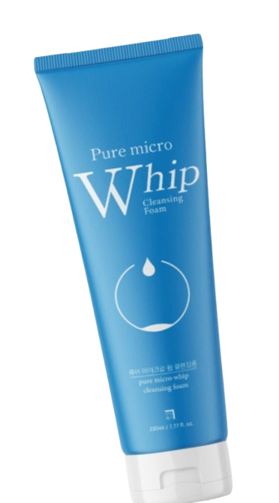
Name : pure micro whip
Description :
A "pure micro whip cleansing foam" is a facial cleanser known for its rich, dense, ultra-fine foam that deeply cleans pores by lifting dirt, oil, and dead skin cells while remaining gentle and hydrating.
How to use :
Wet your face with water.
Take a small amount of cleansing foam on your hand.
Gently massage on face in circular motions.
Rinse well with lukewarm water.
Pat dry with a towel.

